Bash Script 02

- Create a bash script to check if a directory is available or not.
First we have to make a bashscript
Mkdir dir_check
vi scripts
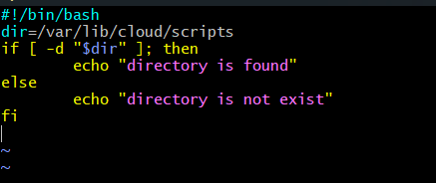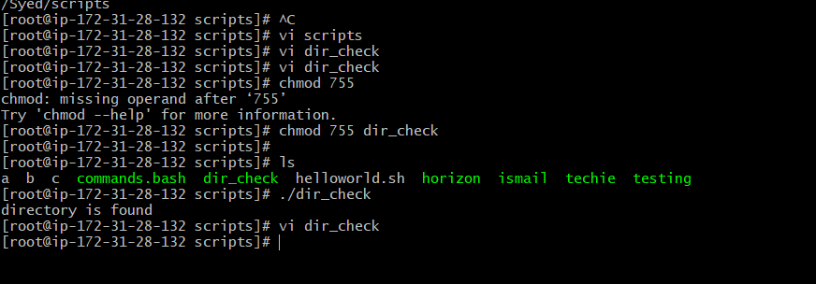

- Create a bash script to create multiple files.
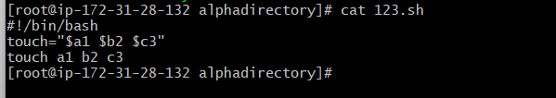

Create a bash script to take a backup of a directory.
Create a file with random name ‘444’
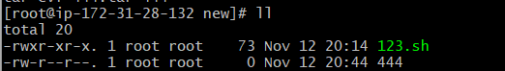
Bashcript to backup a file
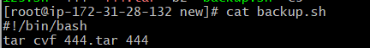
Run the file

Backup file created
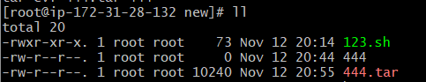

- Create a bash script to install Nginx on an EC2 server.

#!/bin/bash
sudo yum update -y
sudo yum install nginx -y
sudo systemctl start nginx
sudo systemctl enable nginx
echo "Nginx installed and running!"

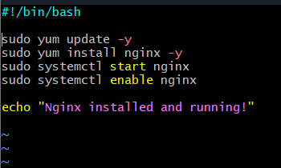
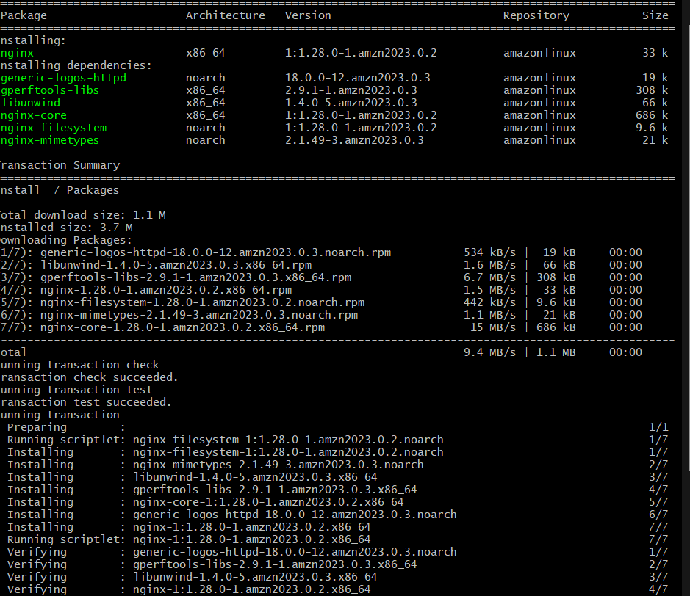

- Create a bash script to install Apache Tomcat on an EC2 server.

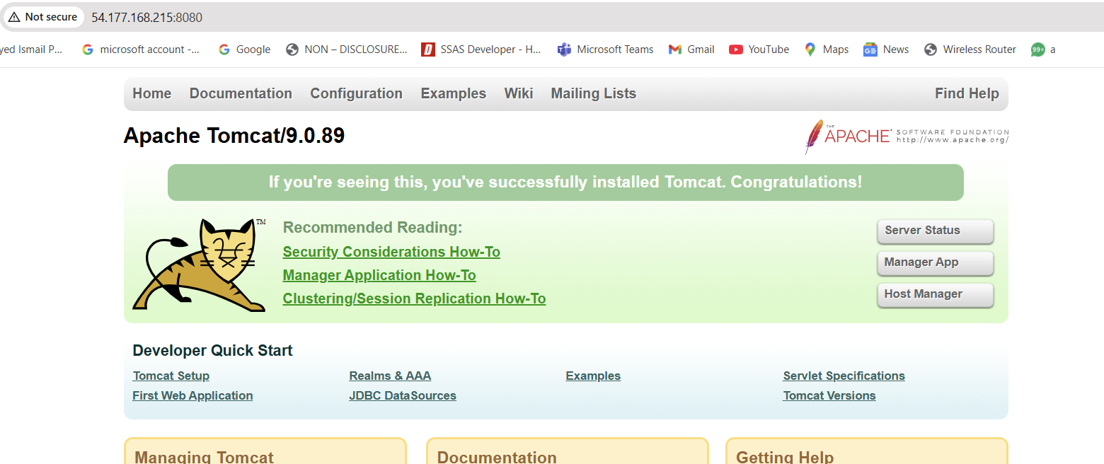

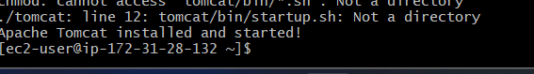

- Create a bash script to check if the Nginx service is running, if not running then script should start the service.
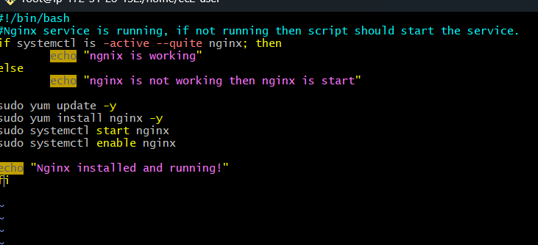
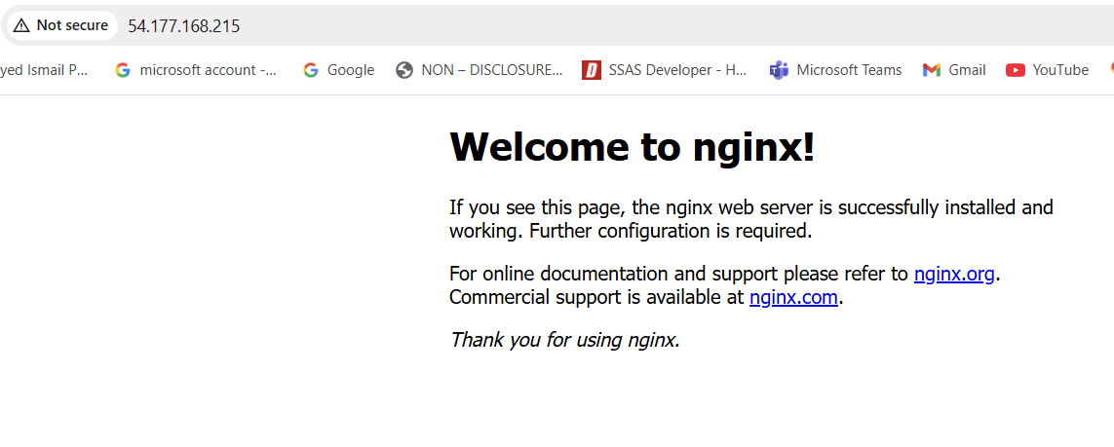
- Create a bash script for a calculator.

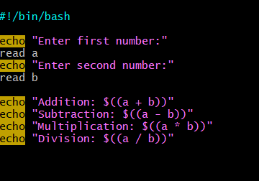
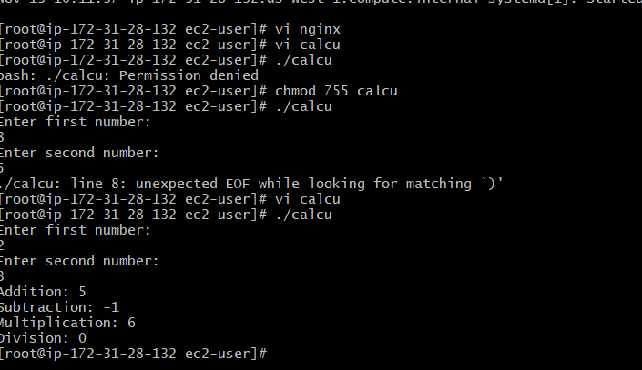
- Create a bash script to check if a directory exists, if not then create a directory.

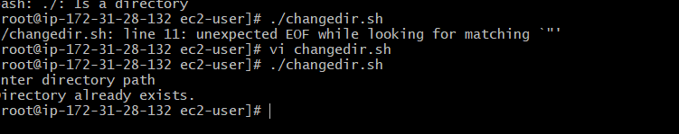
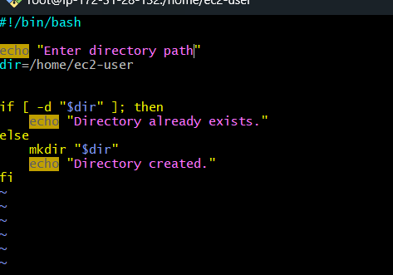

Create a bash script to delete the last 3 lines of a file.
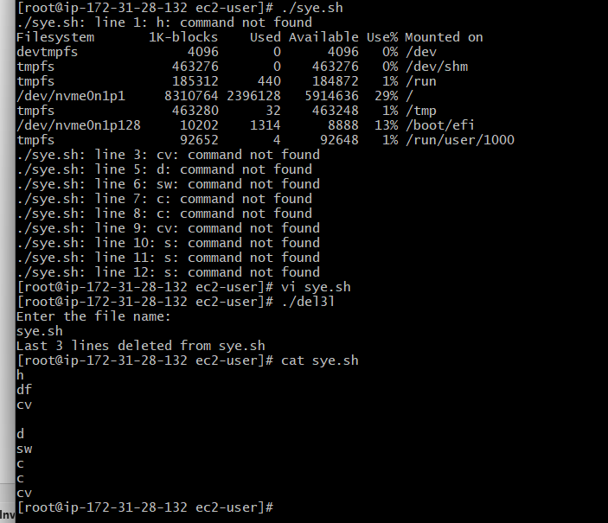

- Bash script to monitor cpu and if it is more than 80% then send email notification.

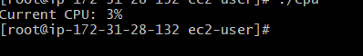
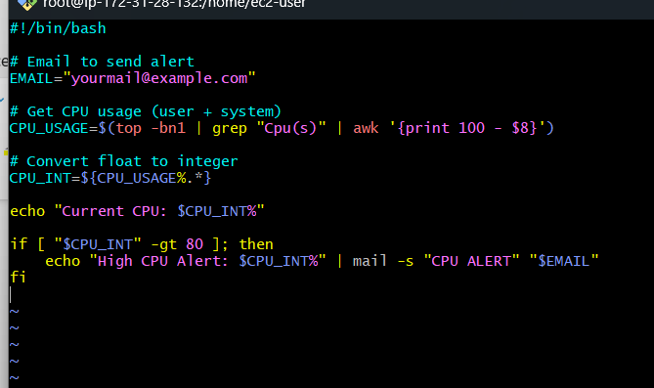
- Bash script to monitor disk space and if it is more than 80% then send email notification.
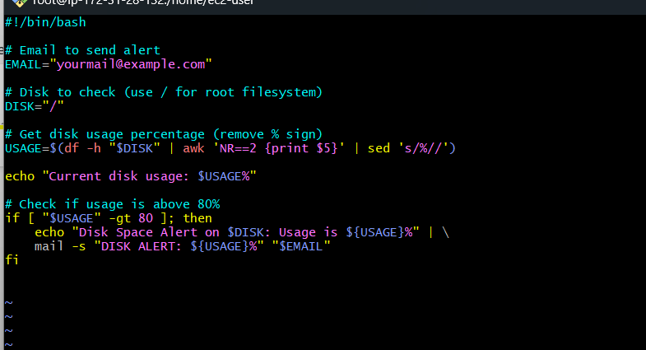
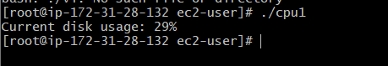
- Bash script to monitor memory and if it is more than 80% then send email notification.
